Program Assessment Review (PAR) / Nuventive

Annual Report

User Guide

2023-24

Contents Page
BACKGROUND AND SCOPE 3
PROCESS 3
1. General Information. 4
2. Mapping. 5
3. Assessment Plan and Results 6
4. Annual Summary and Action Plan. 8
SCHEDULE 9
1. Plan 9
2. Do 9
3. Evaluate 9
GLOSSARY 10

Program Assessment Review (PAR) / Nuventive User Guide

BACKGROUND AND SCOPE
All programs defined by the Pennsylvania State System of Higher Education (the State System) Board of Governors (BOG) Policy 1985-01: Requirements for Initiation or Change of Credit-Based Academic Programs (e.g., degree programs, concentrations, tracks, minors, and certificates) must develop and assess student learning objectives or outcomes (SLOs) to document what students should know or be able to do at program completion and, further, to engage in continuous improvement. To facilitate student learning assessment during integration, an Assessment / Accreditation Functional Implementation Team benchmarked best practices and campus assessment programs and chose to modify the Bloomsburg Program Assessment Review (PAR) process and rename it the Commonwealth University’s (CU’s) PAR in Transition. The process was designed to align with ongoing curricular development and revision of stand-alone programs and to ensure compliance with the Middle States Commission on Higher Education (MSCHE) and the State System’s requirements and expectations.
In 2022-23, this transitionary process included an annual assessment report for each degree program, concentration, track, minor, and certificate that was approved as a part of the new CU program array. The report included a brief description, program student learning objectives, curriculum map, assessment plan, and annual summary and action plan. Programs that submitted the PAR in Transition received an Academic / Academic Support Assessment rubric as a means of feedback intended to help improve the academic planning and assessment processes.
In 2023-24, the PAR Annual Report will be completed in the new CU instance of Nuventive Solutions Premier, eliminating templates and submission to SharePoint. The platform includes tabs for General Information, Curriculum Maps, Assessment Plans and Results, and an Annual Summary and Action Plan based on data collected and reported by the program and /or institutional research (e.g., see Program Review Data section and data dashboards on the Program Assessment web page). The Home and Assessment Plans and Results tabs provide reporting options for the assessment plan and annual report. The 2023-24 results submission and annual report will be again due on May 31.
Once the State System BOG Policy 1986-04-A: Program Review and associated procedures are available, the annual report format may be revised to reflect data requested for five-year reviews but not currently submitted as part of the PAR Annual Report that builds toward the five-year, more comprehensive review.

PROCESS
To complete the PAR Annual Report, please sign in to the CU Nuventive Solutions Premier platform by using the CU SSO. Select your program using the dropdown at the center top of the platform’s screen, which opens to the Home screen, and use the tabs on the left navigation bar to select General Information, Mapping, Assessment Plan and Results, and Annual Summary and Action Plan as described below. Note: the Home screen provides some program summary asessment data and options on the right of the screen to access an assessment report, comprehensive program report (including all areas within the program’s module), and links provided (e.g., to the Academic Program Inventory).

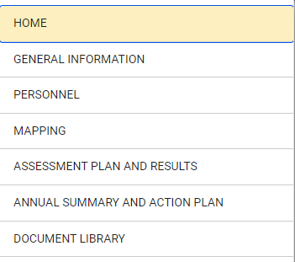

General Information.
- Select General Information from the left navigation bar and review/enter/revise as needed college, department, program name, program type, credential award (e.g., certificate, minor, AS, BS, MA, etc.), and delivery method(s). Click the three vertical dots on the right of the screen, select Edit, and Save any changes.
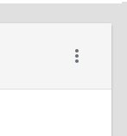
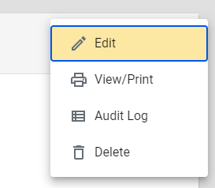
- Provide/revise the Brief Overview of the degree program, concentration, track, minor, or certificate program including any unique features or innovative pedagogy. Save any changes.

Mapping.
  - Select Mapping from the left navigation bar and choose the GE Ed Goals – GE Themes/Goals from the left dropdown to map General Education Program Themes/Goals (in the column) as appropriate to the program student learning objectives (SLOs) (in the row). This demonstrates how institutional goals and program student learning objectives align for all academic programs.
  - Simply click in the cell to mark an “X” where the GE Goals map to program SLOs and Save any changes.
  - Select Curriculum Mapping from the dropdown to map program SLOs to courses.
  - Select course/learning activities (in the column) and map to program SLOs (in the row).
  - Simply click all of the proficiency level(s) (e.g., I, R, M) that apply for a given Course/SLO mapping and Save any changes. Every program SLO should be mapped to at least one course/learning activity.
  - Reorder the list of courses, if desired, in the left column by clicking on the three vertical dots to the right of the title Program SLO Assessment, select order courses, click on the dotted box beside the course name and drag to the desired position. Click Save if you make changes and Close.
  - Assign courses that do not show on the curriculum map by clicking on the three vertical dots to the right of the title Program SLO Assessment, select assign courses, locate the course in the available course list, click the Assign button, click Save if you make changes and Close. If you cannot locate the course or learning experience, contact Shane Jones at sjones@commonwealthu.edu
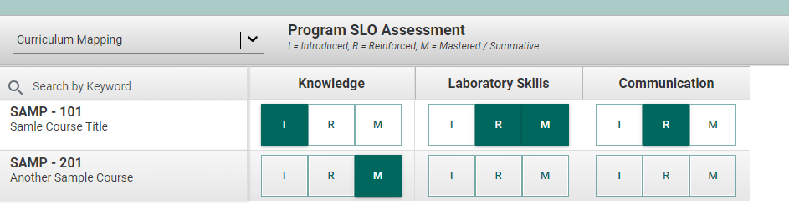
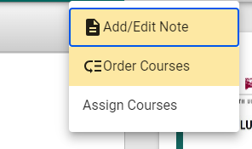

Assessment Plan and Results
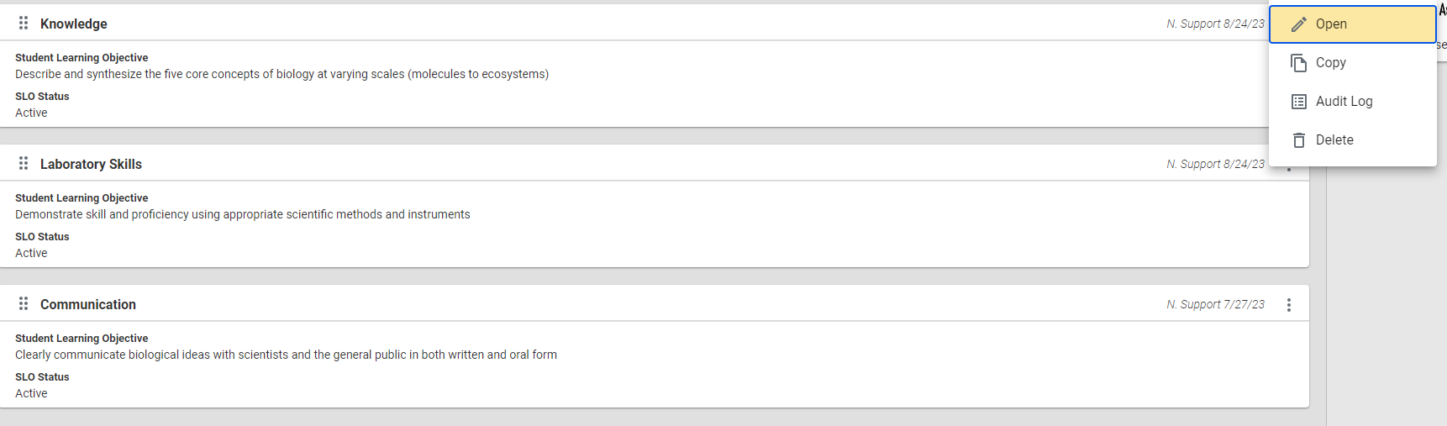
- Select Assessment Plan and Results tab from the left navigation bar to review/revise each SLO and assessment method and enter results. Click three vertical dots to the far right of the SLO NAME and Open the objective you wish to edit/report results.
- Under the Student Learning Objective tab, review/revise the specific learning objective. Review the SLO name, SLO statement, and SLO status and revise as needed. Click Save if you make changes and Close.
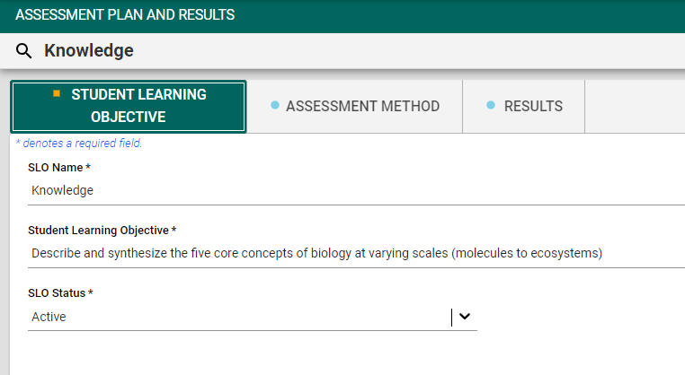

- Under the Assessment Method tab, you can revise the Assessment Method, Method Status, Criterion/Performance Target, and When/How Often Does Assessment Occur by clicking on the three vertical dots on the right of the screen and Open. You can also add a new Assessment Method by clicking the green plus sign. Click Save if you make changes and Close.
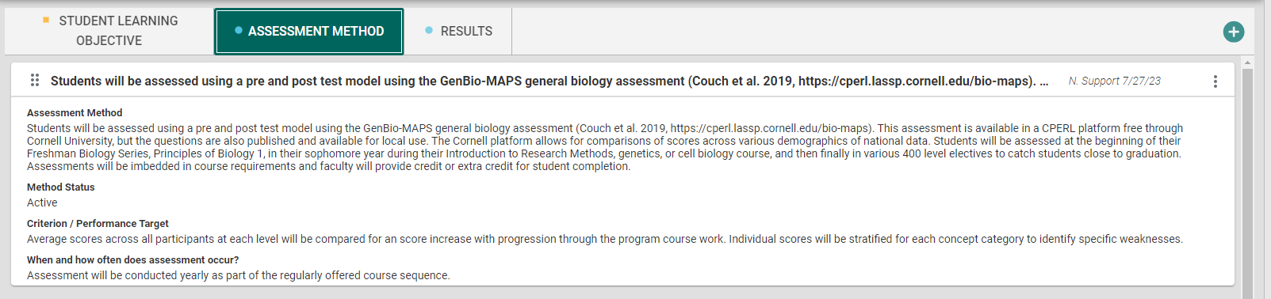
- Under the Results tab, enter/revise results and actions for the reporting year by clicking the green plus sign to add a new result OR the three vertical dots for the reporting year, select Open, and enter the results. Click Save if you make changes and Close.
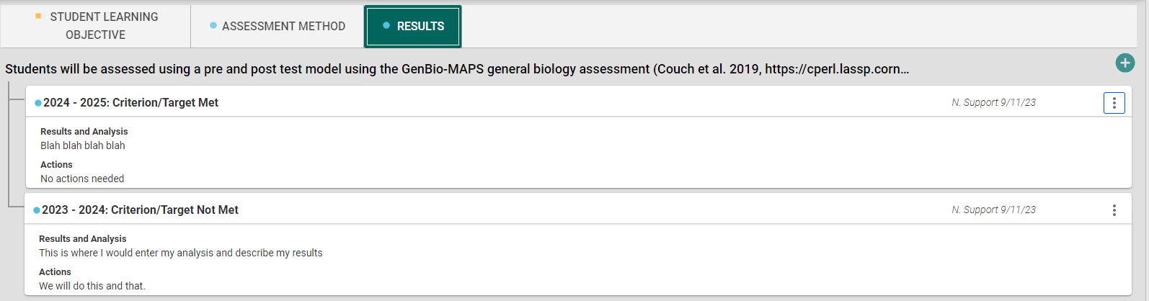
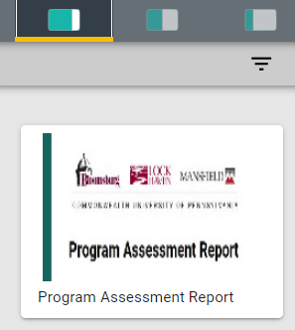
- Generate a program assessment report by clicking on the report icon (see below) on the right side of the Assessment Plans and Results screen. The report includes fields from the student learning objectives, assessment plan, and results tabs in this module.

Annual Summary and Action Plan.
- Select Annual Summary and Action Plan from the left navigation bar. Click three vertical dots on the right of the screen and select Edit.
- Enter a narrative response by clicking in the box below each of the four prompts:
- Summarize the program’s data and trends for CU and campuses. (See Program Review Data and Institutional Research Dashboards.) Please use relevant external data as appropriate.
- Identify the integrated program’s strengths and weaknesses
- Provide a summary of personnel, physical, technology, and financial resources and adequacy of those resources
- Provide an action plan to improve program outcomes, student learning, and the assessment plan for next academic year (3-5 bullet points informed program data, SLOs, resource sufficiency, or other internal/external sources of information/data)
- Click Save and Close. If you want to save work and return later, be sure that you enter at least some text in every box. The system will not allow you to save your work unless each field is populated.
- Upload into the core unit your program’s student and faculty accomplishments as additional evidence of program quality (Word or PDF document). You do not need to upload multiple times for a degree program’s concentrations, tracks, specializations, or related minors.
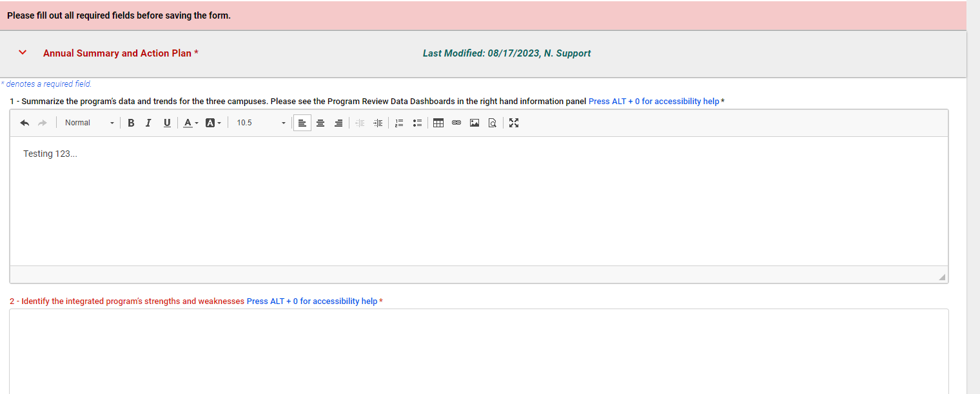
- When ready to submit, change the dropdown to “Yes” for the prompt - Is your annual summary complete and SLO assessment complete? Are you ready to have your PAR Annual Report reviewed?

SCHEDULE

Plan
Follow the user guide and consider results data, feedback (e.g., from the academic assessment rubric), and training when you review/refine the general information, SLOs, curriculum map, and assessment plan.

Do
Implement the assessment plan, collect data throughout the academic year, and report outcomes in Nuventive Solutions Premier as soon as available but no later than May 31.

Evaluate
Analyze results to inform actions and complete/submit remaining sections of PAR Annual Report in Nuventive Solutions Premier by May 31. After submission, the OIE and faculty liaison will provide feedback on the annual report to inform faculty planning (via an assessment rubric), training sessions, and the academic assessment committee recommendations. Deans can access Nuventive and any of their colleges’ programs therein, but they will also receive a summary report so they can:
- know which programs submitted a PAR Annual Report in Nuventive
- review the rubric ratings and comments on each section of the PAR for the College and each program
- compare results to last year’s ratings to see where improvements have occurred
- understand where opportunities for improvement exist for the college and its programs
- follow up with programs that did not submit or submitted reports with significant omissions or deficiencies to increase the number and quality of submissions
- acknowledge programs that submitted exemplary reports

Deans can view college-level analytics and reports by selecting their college on the dropdown in the center top of the platform’s screen, viewing the program assessment summary dashboard, and generating a program assessment report for all programs in the college by clicking on the report icon on the right side of the screen.

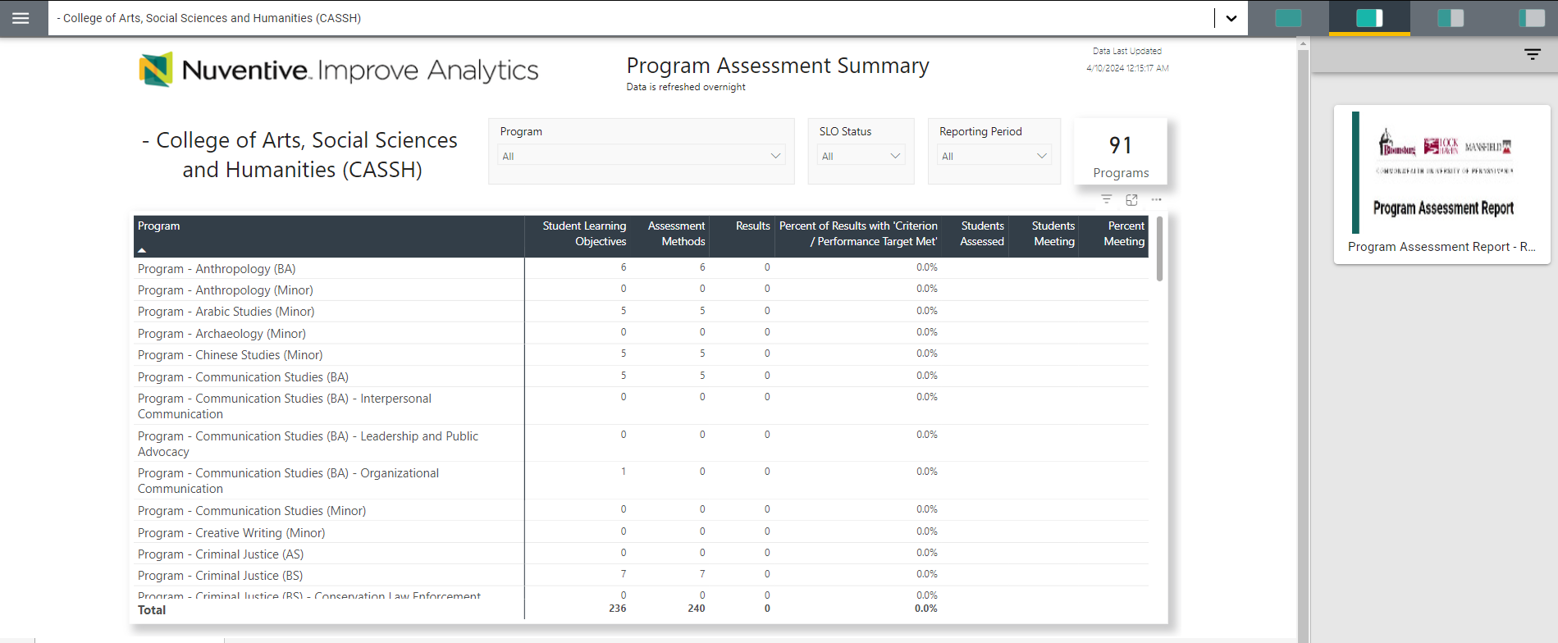

GLOSSARY
Academic Program – Per BOG Policy 1985-01-A, an instructional program leading toward a certificate, associate’s, bachelor’s, master’s, or doctoral degree or resulting in credits that can be applied to one of these degrees. Per BOG Policy 1984-04-A, academic programs include all academic degree programs (academic majors) along with any associated track/concentrations, academic minors, certificates, and the general education program.

Assessment - systematic process of gathering and using appropriate information to refine programs and improve student learning.

Assessment Cycle - stages to plan, conduct, understand, and act on assessment activities and results.

Assessment Grid - (i.e., Program Assessment Plan; also applies to assessment plans for any degree program, concentration, track, minor, and certificate) template that lists the administrative details for each SLO, the student assessment (method, criteria, when/how assessed), the results of the assessment (criteria met/not met and actual results), actions taken using the results to improve student learning, and closing the loop (documenting actual changes in student performance).

Benchmarking - the process of establishing shared standards (or benchmarks). This may be done with reference to local standards and local examples of student work but should be informed by external standards.

Bloom’s Taxonomy - a classification system that defines a hierarchical ordering of cognitive, affective, and psychomotor skills. The cognitive domain includes six levels of cognition and is used primarily for classifying educational learning objectives.

Continuous Improvement - ongoing effort to assess and improve student learning. The four phases of continuous improvement are Plan, Do, Check, and Act (PDCA Cycle).

Criterion or performance targets - established criteria to determine level/proficiency of performance.

Curriculum Mapping - the process of creating a synoptic view of the curriculum, documenting curricular opportunities that enable students to reach the program’s learning goals. A curriculum map shows where students are introduced to the program’s central ideas, skills, and habits of mind, where those objectives are reinforced, and where students display mastery of these objectives.

Embedded Assessments - program or institutional assessments embedded into course work.

Formative Assessment - data gathered on student learning during the instructional process. It helps an instructor or program identify areas of weakness and strength and to modify instruction accordingly. Any assessment can be formative if its purpose is to improve student learning as instruction continues.

Institutional Assessments of Student Learning - overarching learning goals for all students, regardless of major, generally delivered through the general education program or curriculum in which case assessment, at the institutional level, is synonymous with general education assessment.

Key Performance Indicators (KPIs) - measures or indicators of outputs or outcomes and may also be considered leading (i.e., predictive of performance) or lagging (i.e., outcome of performance) indicators. Typically, KPIs are related to outcomes assessment.

Measures of Student Learning, Direct - a measure of student learning based directly on tangible, specific evidence seen in students’ actual performance. Direct measures include exams, papers, systematic observations of relevant student behavior, reports from internship supervisors, standardized test scores, etc.

Measures of student learning, Indirect - a measure of student learning based upon data presumed to correlate with student learning but not directly indicative of it. Indirect measures include student or alumni ratings of their knowledge or learning experience, surveys, focus groups, exit interviews, etc.

National Survey of Student Engagement (NSSE) - standardized survey of student experiences that are known to positively impact student success

Nuventive Improve - a software platform that allows institutions to document academic and administrative assessment plans, results, supporting documents, and actions for management planning, assessment, and quality improvement processes.

Program Assessment Review (PAR) - includes both annual and four-year program assessment review process for any degree program, concentration, track, minor, and certificate by reviewing the assessment of student learning as well as evaluating departmental operations and resources in the context of student success.

Programmatic Accreditation - organizations that accredit specific programs as recognized by the Council for Higher Education Accreditation (CHEA).

Qualtrics - online survey software

Rubric - a scoring guide used to standardize assessment of student work by identifying a limited number of criteria and providing for each criterion explicit statements about the expected qualities of performance at each point on a scale or rank in an ordered scoring system

Scaffolding - a set of steps and supports that help students move from one level to another and give them guidance about that route to take.

Simple Random Samples - a sample in which every student has an equal chance of selection.

Student learning objective or outcome (SLO) – knowledge, skills, attitudes, and habits of the mind that students have and take with them when they complete a program of study. Student learning outcomes exist at three levels (i.e., institutional, program, and course) and are interconnected. Frequently, the terms objective and outcome are used interchangeably (as are goal and objective). Thus, SLO may refer to student learning objectives or student learning outcomes, depending on local usage.

SMART Goals – goals that incorporate Specific, Measurable, Attainable, Relevant and Time-based criteria to help focus efforts and chances of achieving the goal.

Summative Assessment - data gathered on student learning at the end of a course or program as a basis for judging student knowledge and skills. Any assessment can be summative if its purpose is to evaluate student learning and instruction after instruction has occurred.

VALUE Rubrics- 16 rubrics developed by the American Association of Colleges and Universities (AAC&U) and organized around relevant student learning.

